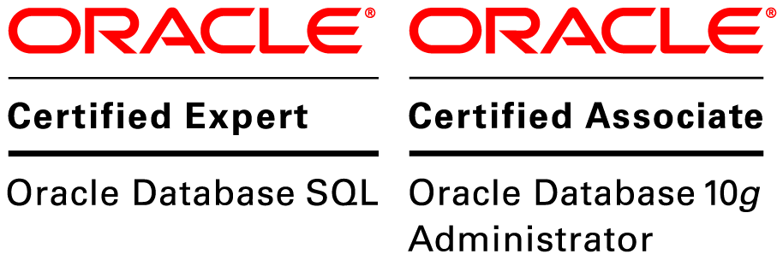
Khushboo Kaushal
Contact No.: (+91)9604185408
E-Mail: askhushbookaushal@gmail.com

CAREER SNAPSHOT

PROFESSIONAL SUMMARY

Oracle Certified Associate with around 5+ years of experience as DBA and PLSQL Developer in design, development, testing, performance tuning and wide knowledge of a variety of programs and procedures.

CORE QUALIFICATIONS

- Knowledge in Unix Shell Programming and SQL*Loader.
- Responsible for migrating data from one database to another.
- Proficient problem-solver who envisions business and technical perspectives to develop workable solutions.
- Skilled professional PLSQL development, Oracle testing and Performance Tuning.
- Sound programming skills to Develop, design, test and implement complex database programs.
- Knowledge of the SDLC including requirement analysis, design, development, testing, debugging & trouble- shooting.
- Excellent communications and interpersonal skill.
- Hands on experience of ETL process.
- Good team player and working individually with less supervision.
- Expert in Resolving Migrated Data Issues

CAREER CONTOUR

Jun’21 – Till Date: Database Engineer at MCX on Payroll of Cinntra Infotech Solution Pvt. Ltd.
Dec’18 – Nov’20: Senior Software Developer at Modus Information Systems Pvt. Ltd.
May’18 – Sep’18: Software Developer at IBM on Payroll of DynPro India Pvt. Ltd.
Apr’16 – Jan’18: Database Migrator at Riflexions Consulting Pvt Ltd, Bangalore.

ACADEMIC CREDENTIALS

2012 Master of Computer Applications from Technocrats Institute of Technology, RGPV, Bhopal.
2009 Bachelor of Commerce from Sant Hirdaram Girls College, Bhopal.

TECHNICAL CERTIFIACTIONS

2014 Got OCE (Oracle Certified Expert) in Oracle Database SQL.
2014 Got OCA (Oracle Certified Associate) in Oracle Database 10g Administrator.
Oracle Test ID: OC1362133

SKILLS SET

Programming Languages Oracle SQL, PL/SQL, MS SQL
Technologies UNIX Shell Scripting, AIX Server
Tool Oracle SQL Developer, SQL*Plus, Oracle 10g/11g/12c, Eclipse, SQL Server, DB2
Database Oracle 10g, 11g, 12c SQL Server
Operating System Unix, Windows PC Family

PROJECTS EXECUTED

Title | Data Migration
Platform | Unix, Windows
Tools | SQL Server, DB2, Ms Excel
Location | Mumbai, India
Period | Jun’21 – Till Date
Role | Database Engineer
Responsibilities | - Analysing migration requirements.  - To develop migration requirements, gathered business logic, and extract data for migration.  - Performing Unit testing of developed system.  - Conducting data structures and movement evaluations.  - Updating and recreating existing data scripts and processes for better performance with accuracy.

Title | FEBA - E-Banking Migration
Client | Industrial Development Bank of India (IDBI)
Language | Oracle
Platform | Unix, Windows
Tools | Oracle SQL Developer, SQL*Plus, Ms Excel, WinSCP, Putty, Eclipse, SVN
Location | Mumbai, India
Period | Dec’18 – Nov’20
Role | Senior Database Migrator
Responsibilities | - To develop business requirements, gathered business logic, and implement it.  - For data accuracy analyse and debug data.  - Performed Unit testing of developed system.  - Performed data migration enforcement tasks.  - Furnished support to field services and technical groups as and when needed.  - Updating and recreating existing data scripts and processes for better performance with accuracy.  - Data migration from old version to new version according to Application and Clients requirement.  - Executed data migration in coordination with management and technical services personnel.

Title | ECDW
Client | AT&T
Platform | Unix (AIX Server), Windows, Unix Shell Scripting
Tools | Oracle SQL Developer, SQL*Plus, Ms Excel, SVN, SQL*Loader, Putty
Location | Bangalore, India
Period | May’18 – Sep'18
Role | Database Developer
Responsibilities | - Develop business requirements, extract and load them using SQL*Loader.  - Develop business codes as required by the Client to be executed.  - Performed Unit testing of required data.  - Updating and recreating existing data scripts and processes for better performance with accuracy.

Title | FEBA - E-Banking Migration
Client | Union Bank of India (UBI)
Platform | Unix (AIX Server), Windows
Tools | Oracle SQL Developer, SQL*Plus, SQL Server, Ms Excel, Eclipse, WinSCP, Putty, SVN
Location | Mumbai, India
Period | Apr’17 – Jan’18
Role | Database Migrator
Responsibilities | - To develop business requirements, gathered business logic, and implement it.  - For data accuracy analyse and debug data.  - Develop business codes as and when required which are getting used in other Banks too.  - Performed Unit testing of developed system.  - Performed data migration enforcement tasks.  - Furnished support to field services and technical groups as and when needed.  - Updating and recreating existing data scripts and processes for better performance with accuracy.  - Data migration from old version to new version according to Application and Clients requirement.  - Executed data migration in coordination with management and technical services personnel.

Title | E-Banking Migration
Client | Deutsche Bank
Platform | Unix, Windows, Cloud Server
Tools | Oracle SQL Developer, Oracle PLSSQL Developer, SQL*Plus, Ms Excel, Eclipse, , WinSCP, Putty, SVN
Location | Mumbai, India
Period | Apr’16 – Apr’17
Role | Database Migrator
Responsibilities | - Analyse the business requirements.  - Developed business codes as per client’s requirements and application functionality.  - Maintained existing data migration program with upgrades and enhancements.  - Performed data migration enforcement tasks.  - Furnished support to field services and technical groups as and when needed.  - Utilized existing data scripts and processes.  - Conducted data structures and movement evaluations.  - Executed data migration in coordination with management and technical services personnel.  - Understood and adopted the clients work environment to work on cloud server.

CERTIFICATIONS PROGRAMMES ATTENDED

- Certification at NIIT:
Completed DBA Course from NIIT, Pune, in 2014.
- Certification for Corporate:
Executive Program in Service Management from Elements Akademia, Bhopal, in the year 2008-2009.

PERSONAL PROFILE

Nationality India
Language English, Hindi
Permanent Address E-504, Annapurna Complex, PnT Square, Near Kotra Sultanabad Road, Bhopal (M.P.)
Passport Number Z3763241

